J3ZZ MONITORS : Vocals, Bass, Violin(s), Speaker-1, Speaker-2, MoogMix, , iPad, Loop, Rx,
WifI : VIBROTANICA_5G
RME : DUREC + REC INGE SON AUDIO + INSTA360
RADIAL REAMP
LOOPER MIDI IN from KENTON MIDI OUT to Timeline
FX Jacks IN : Octaver Jacks OUT : Black Hole MIDI IN : Timeline
MIDI CHAIN midiHUB FX > Kenton > Boomerang > Timeline > (Microcosm > Pitchfactor) > BlackHole
ABLETON
Settings : RME chosen as device I/O
Link
Put down SENDS A/B for VOCALS MIX, Kickbass , Plback-iPads, looprxtrn, fxrtrn, violin, ipad, MoogMix
Adjust water levels
BOOMERANG PEDAL
Sync + Free mode + Volume of each loop to ¾
iPad
TC TRANSFORMER : Load : Transpose : G minor Pent
XYNTHSIZR : CLEAR + low pass filter to the max
PATTERNING : CLEAR + low pass filter to the max
MOOGS
SETTINGS
M32 : CUTOFF to 0 + Volume to 0 + Mix VCO to 0
MINITAUR : CUTOFF to 0 + Volume to 0
ETC : trigger adjust + mode 55
PEDALS : SETUP
PLANTS : adjust trigger

CH | SOURCE | WHAT IS GOING ON? | WHAT TO DO?
01 | Speaker-1 | Water+Moving(Birds+Chimes+Noises)+plantsynth | Mixed by J3ZZ
02 | Speaker-2 | Water+Moving(Birds+Chimes+Noises)+plantsynth | Mixed by J3ZZ
03 | Speaker-3 | Water+Moving(Birds+Chimes+Noises)+plantsynth | Mixed by J3ZZ
04 | Speaker-4 | Water+Moving(Birds+Chimes+Noises)+plantsynth | Mixed by J3ZZ
05 | Violin | Dry violin | Add REVERB etc. Send to the front
06 | MoogMix | Moog synth | Send to the front
07 | Bass | Kick + Bass | Send everywhere (mono)
08 | iPad-L | pads, drums, synths, spatial | Send to the front
09 | iPad -R | pads, drums, synths, spatial | Send to the front
10 | Vocals-L | Vocals | Send everywhere (stereo front)
11 | Vocals-R | Vocals | Send everywhere (stereo back)
12 | Loop-L | Looped violin with effects | Send to the front
13 | Loop-R | Looped Violin with effects | Send to the front
14 | Fx-L | Effects | Send to the front
15 | Fx-R | Effects | Send to the front
16 | Vocal-HF | SHURE BETA 58 HF | Send to the front
17 | Violin-direct | Dry violin | Add REVERB etc. Send to the front
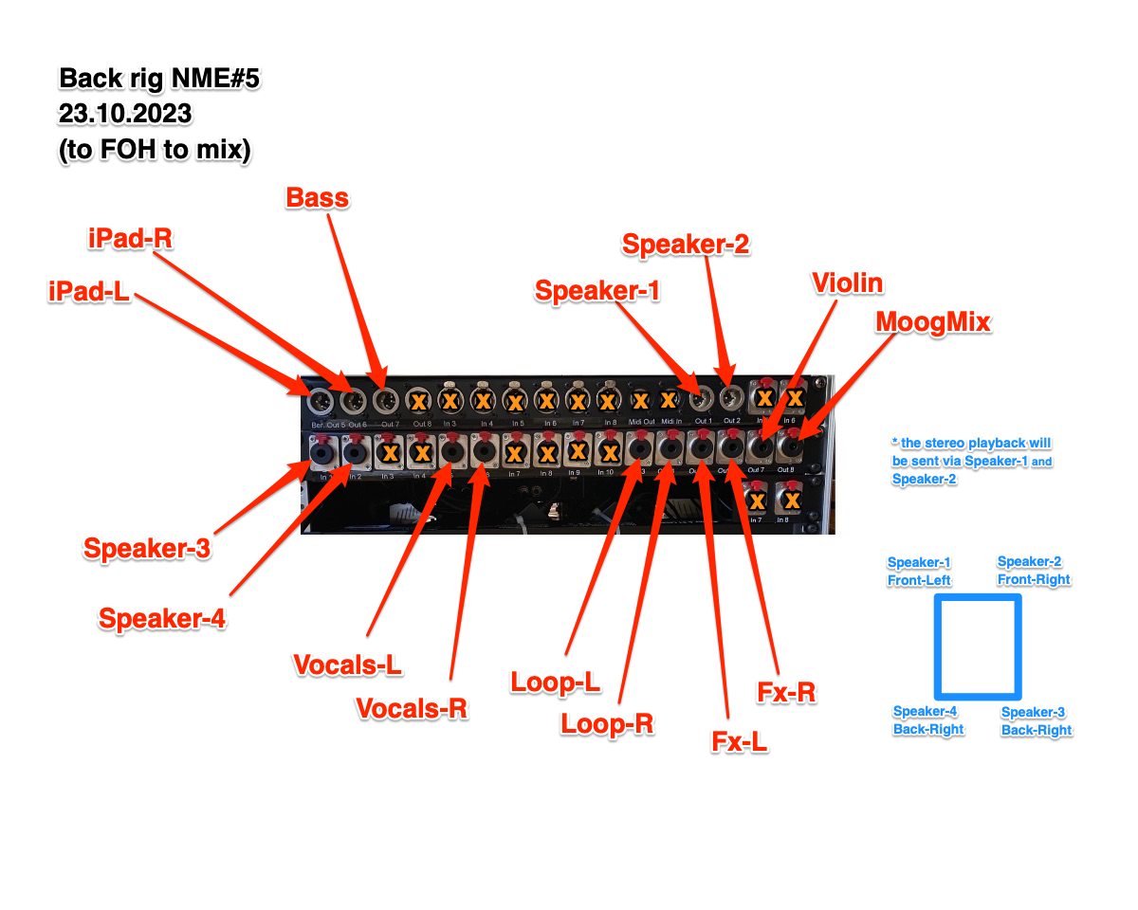

Stage plot

Power 16 amp independent circuit
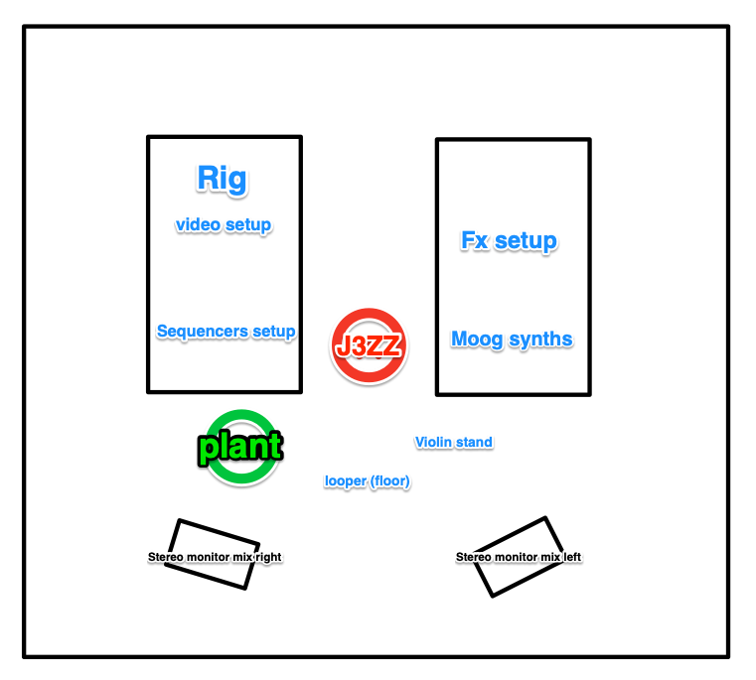

Outputs
01 | Main-L (Sub) - Speaker-1 Front-Left
02 | Main-R (Sub) - Speaker-2 Front-Right
03 | Speaker-3 Back-Right
04 | Speaker-4 Back-Left
05 | Stereo monitor - L J3ZZ
06 | Stereo monitor - R J3ZZ

Out | In | units | XX chargers including iPad and laptop
 |  |  | violin
 |  |  | Violin stand
 |  |  | Dpa 4099v
 |  |  | Akg B29L + C411L
 |  |  | iPad Pro 12,9+ charger 45W
 |  |  | RADIAL DI Stage bug
 |  |  | RADIAL DI J48 STEREO
 |  |  | Pedal Board
 |  |  | Cable TRS stereo 6,5mm - TRS stereo 6,5mm
 |  |  | Cable TS mono 6,5mm - TS mono 6,5mm
 |  |  | Cable midi
 |  |  | Cable XLR male – XLR female
 |  |  | Cable TRS stereo 6,5mm – XLR male
 |  |  | Cable UM-ONE Roland Midi – USB + Apple camera kit usb
 |  |  | cable patch TS mono 6,5mm - TS mono 6,5mm
 |  |  | Cable USB-A – USB-B
 |  |  | cable patch 3,5mm
 |  |  | cable USB-C <> lightning
 |  |  | cable apple 2m USB-C <> USB-C
 |  |  | Pedal BOOMERANG + charger
 |  |  | Pedal RADIAL TONEBONE PZ PRE+ charger
 |  |  | Pedal tc electronic POLYTUNE +
 |  |  | Power strip
 |  |  | SANDISK DUREC USB KEY
 |  |  | SYNTH MOOG MINITAUR + charger
 |  |  | SYNTH MOOG MOTHER32 + charger
 |  |  | SYNTH MOOG DFAM + charger
 |  |  | KENTON PRO SOLO Mk3 + charger
 |  |  | midiHUB
 |  |  | 1 ETC critteri + charger
 |  |  | Vibrotanica box + TENS cables + sensors
 |  |  | Router Wifi tp-link + charger
 |  |  | Rouleau Gaffer rose
 |  |  | J3ZZ RIG in 4u flycase
 |  |  | HUB USB-C
 |  |  | Laptop MBpro 16”
 |  |  | Camera INSTA360 + selfie stick + charger apple 30W
 |  |  | SSD 2To Vibrotanica + cable USB-C - USB-C
 |  |  | SSD 2To TEMP + cable USB-C - USB-C
 |  |  | Tripod MANFROTTO
 |  |  | Auditive ear protection
 |  |  | diable
 |  |  | DUREC usb key sandisk
 |  |  | Casque audio beyerdynamic
 |  |  | Novation launchkey XL + usb cable
 |  |  | Novation Launchpad + usb cable
 |  |  | Deluge synth + cables
 |  |  | Cable XLR female <> TRS stereo 6,5mm
 |  |  | HDD MyAudioLibs + cable usb sata
 |  |  | Push2 + charger + cable usb
 |  |  | Roli Seabord + cable usb c
 |  |  | USB hub (white) + charger + cable usb
 |  |  | ART phantom power +48v
 |  |  | Radial DI J48 stereo
 |  |  | Computer mouse USB
 |  |  | Casio Label printer
 |  |  | Screwdriver set
 |  |  | Universal charger
 |  |  | Lampe frontale
 |  |  | Chargeur 67 w
 |  |  | Bol tibetain + baton

